Mathematical working out

# Intersection points circle and line

## Formulas

## Solution

### Simplified form

# Reflection vector on circle

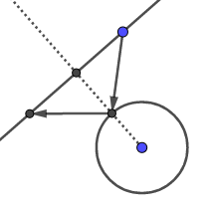

# Intersection of 2 line

## Formulas

### Functions line

## Solution

### Long form

### Simplified form